**Pre-questionnaire**

Before starting the experiment, we ask you to take a minute and answer this brief questionnaire to ascertain your profile and background, so that the final results can be effectively interpreted and analyzed. Thank you.

For questions 2 to 6, each answer should be rated as follows:

1 (Strongly Disagree)

2 (Somewhat Disagree)

3 (Neither Agree nor Disagree)

4 (Somewhat Agree)

**1)** Enter your subject number *

_________________________

**2)** I have considerable experience with: software development *

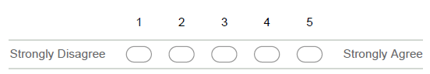

**3)** I have considerable experience with: component development *



**4)** I have considerable experience with: the implementation of software product lines *



**5)** I have considerable experience with: the use of VariaMos *



**6)** I have considerable experience with: developing SPL projects with fragment-oriented

programming *



**7)** Do you work in IT? What specific area? How many years of experience do you have? *

___________________________________________________________________________

___________________________________________________________________________

___________________________________________________________________________